VS Code Installation for Fiori
download vs code , node js , connection via environment variable
install extensions in vs code
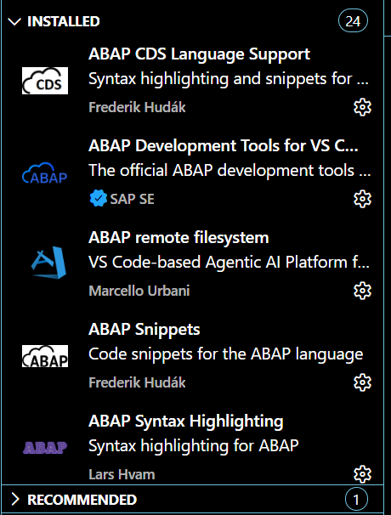
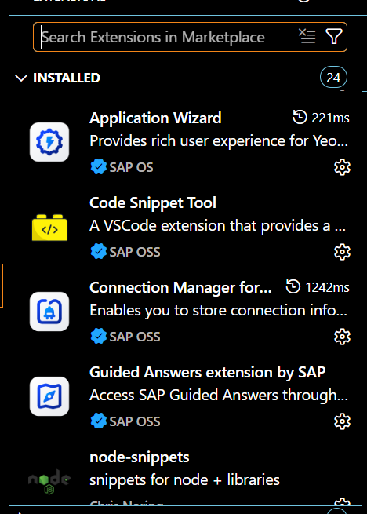
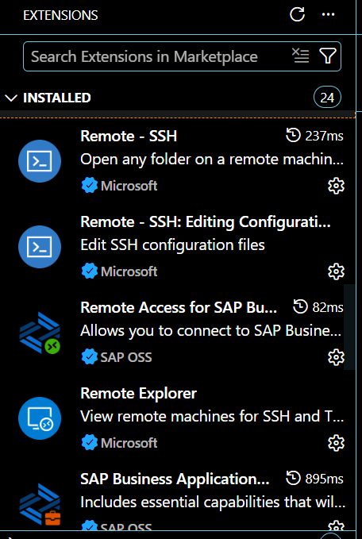
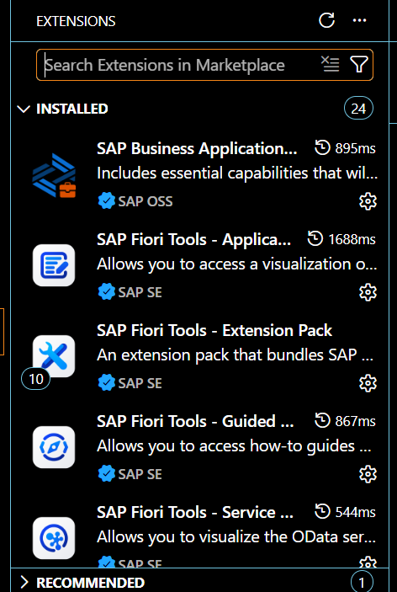
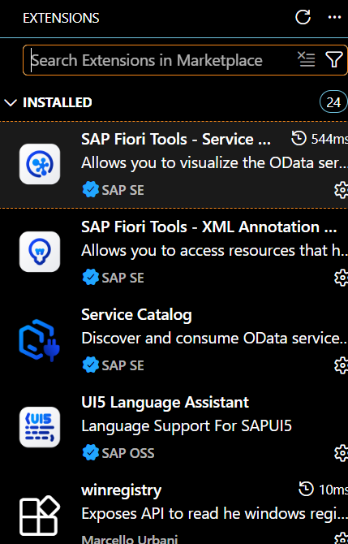
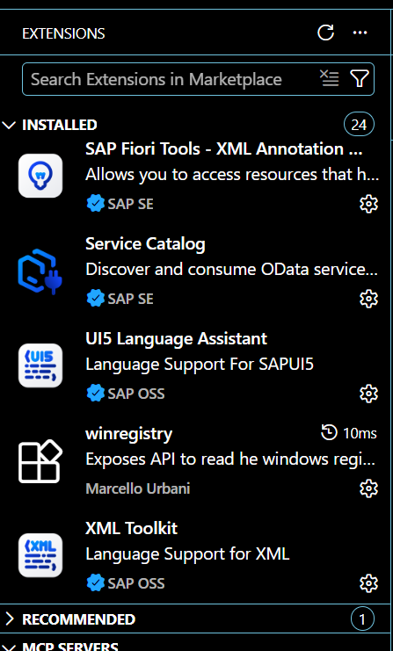
now restrt VS Code
Create List Report Page
ctr+shift+P
Application generator->select list report and next
https://172.31.8.131:44301/sap/opu/odata4/sap/zsb_materials/srvd/sap/zsd_material/0001/
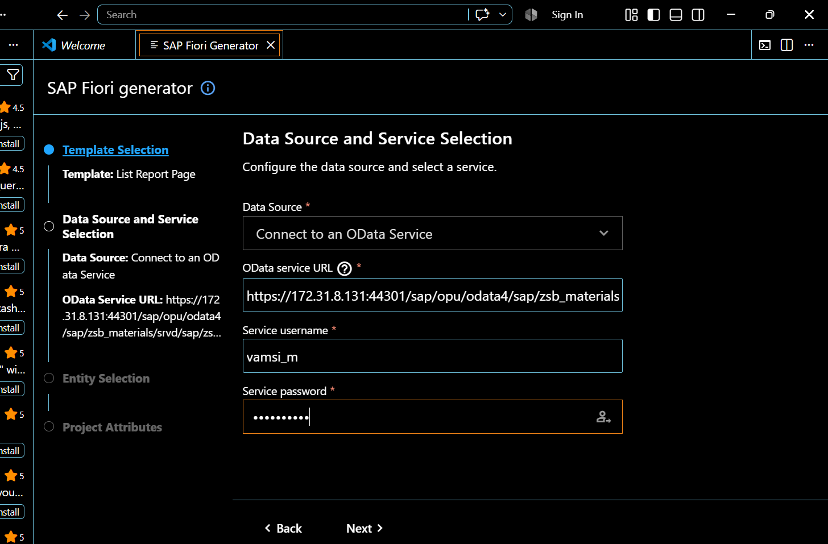
https://172.31.8.131:44301/sap/opu/odata4/sap/zsb_materials/srvd/sap/zsd_material/0001/
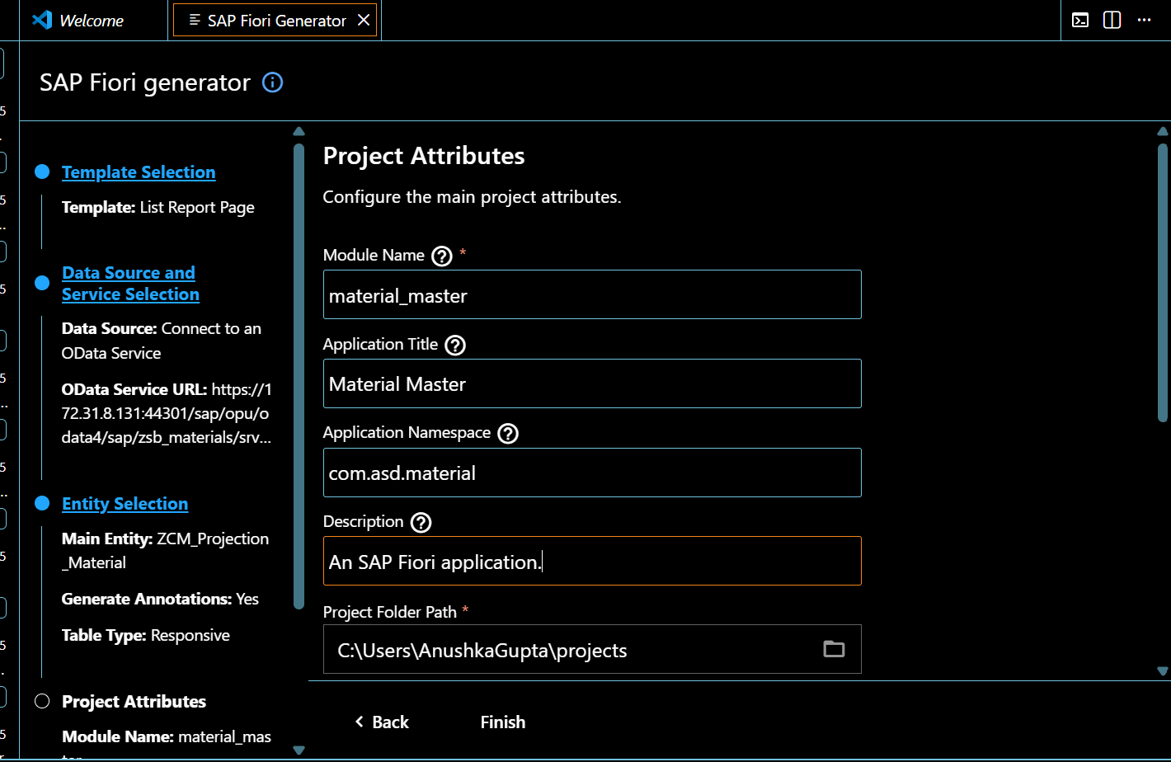
preview ->start-noflp(index.html)
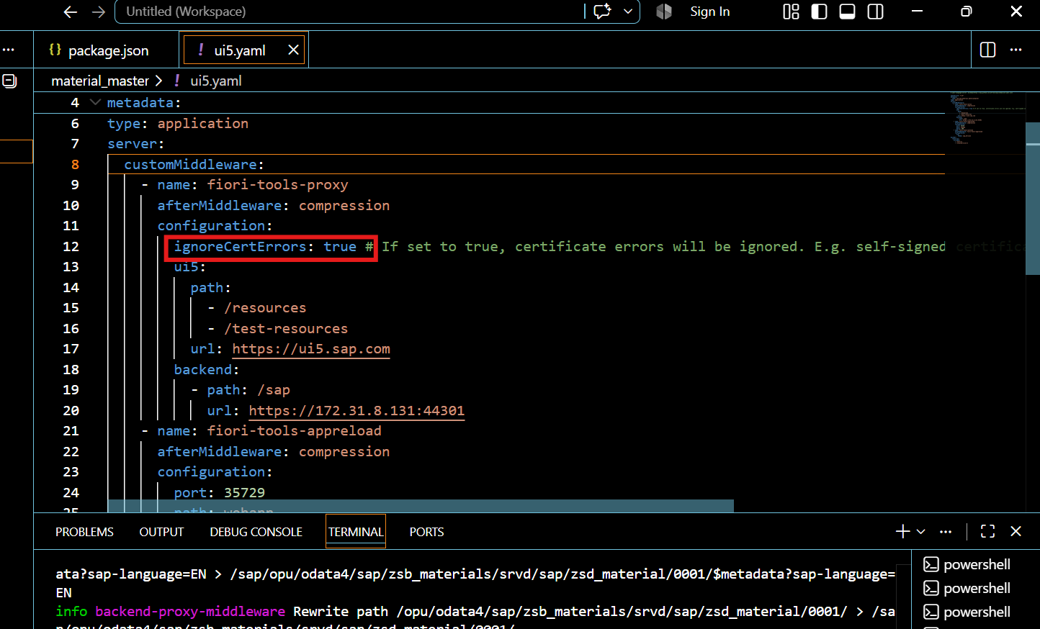
make ignorecerterrors as true
terminal prompt : npm.cmd run start
for stopping ctrl+c

install DIST file :
open new terminal and open cmd prmt
prompt : npx ui5 build -a (it will download the file)
it will install DIST file.,check that file explorer in (your system)the above path mentioned in cmd prmpt.
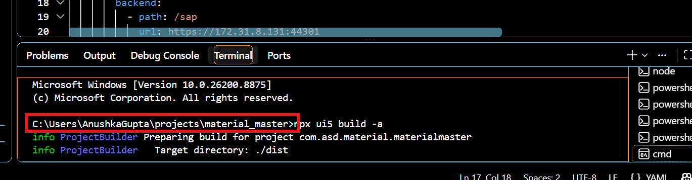
Upload to ABAP Repository
Run report : /UI5/UI5_REPOSITORY_LOAD
in external codepage we should fill UTF-8
FIORI launchpad Configuration
1.semantic object creation
in t code /UI2/SEMOBJ maintain the entry as required
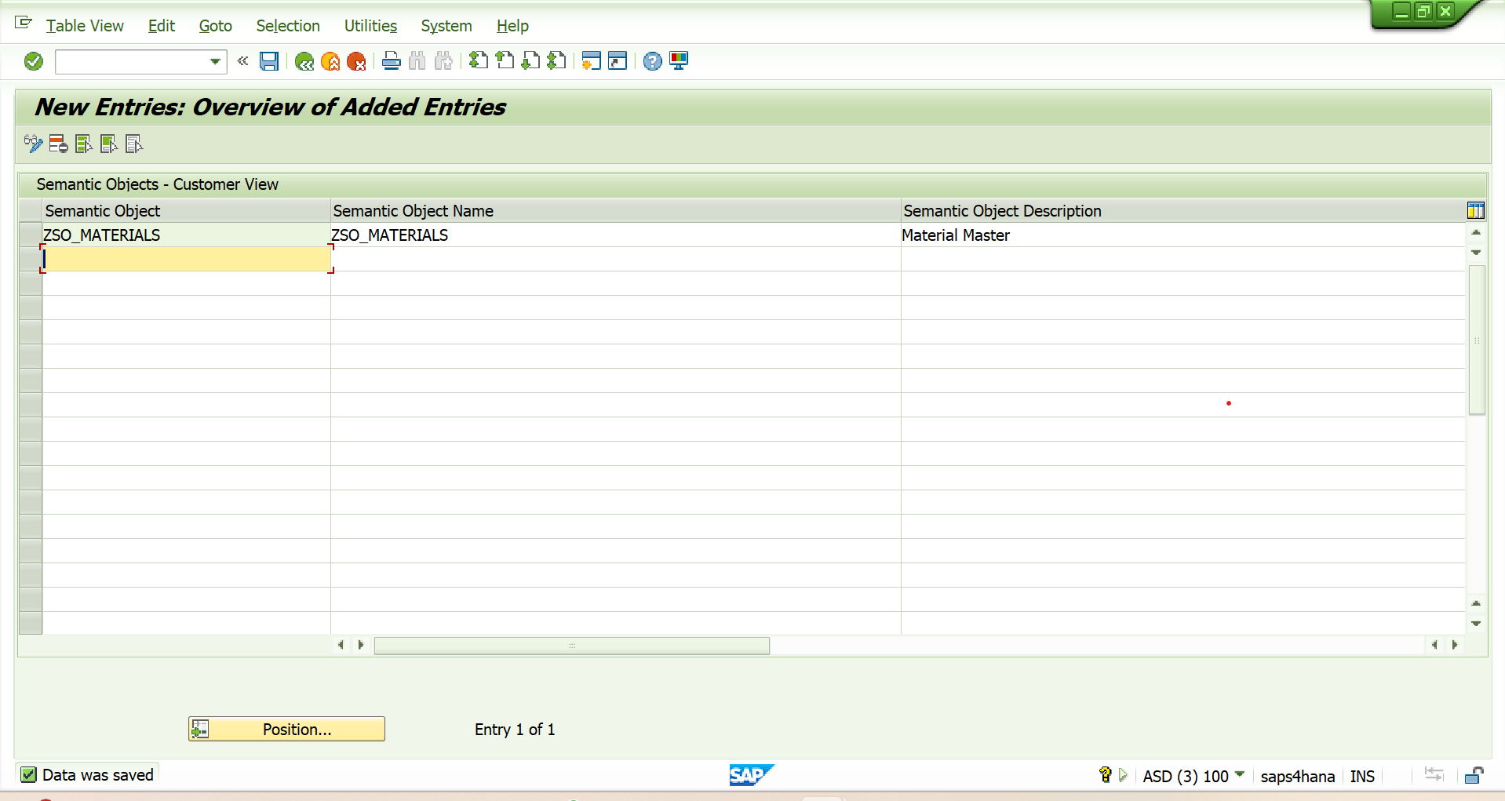
2.open firori launchpad : /UI2/FLPD_CONF
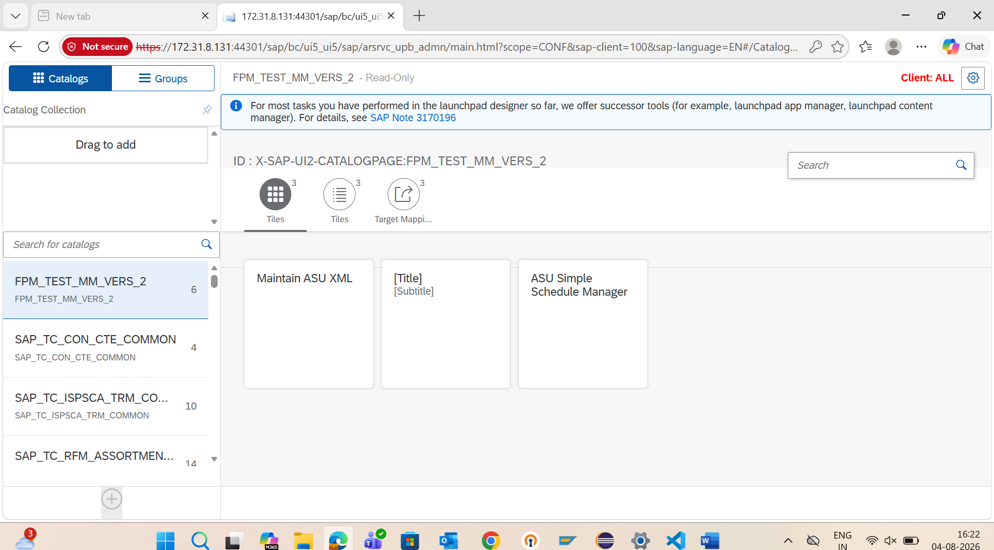
You may seek help from basis team if you face any transport, package or class related issue.
Create Catalog : fill catalog title and id and save.
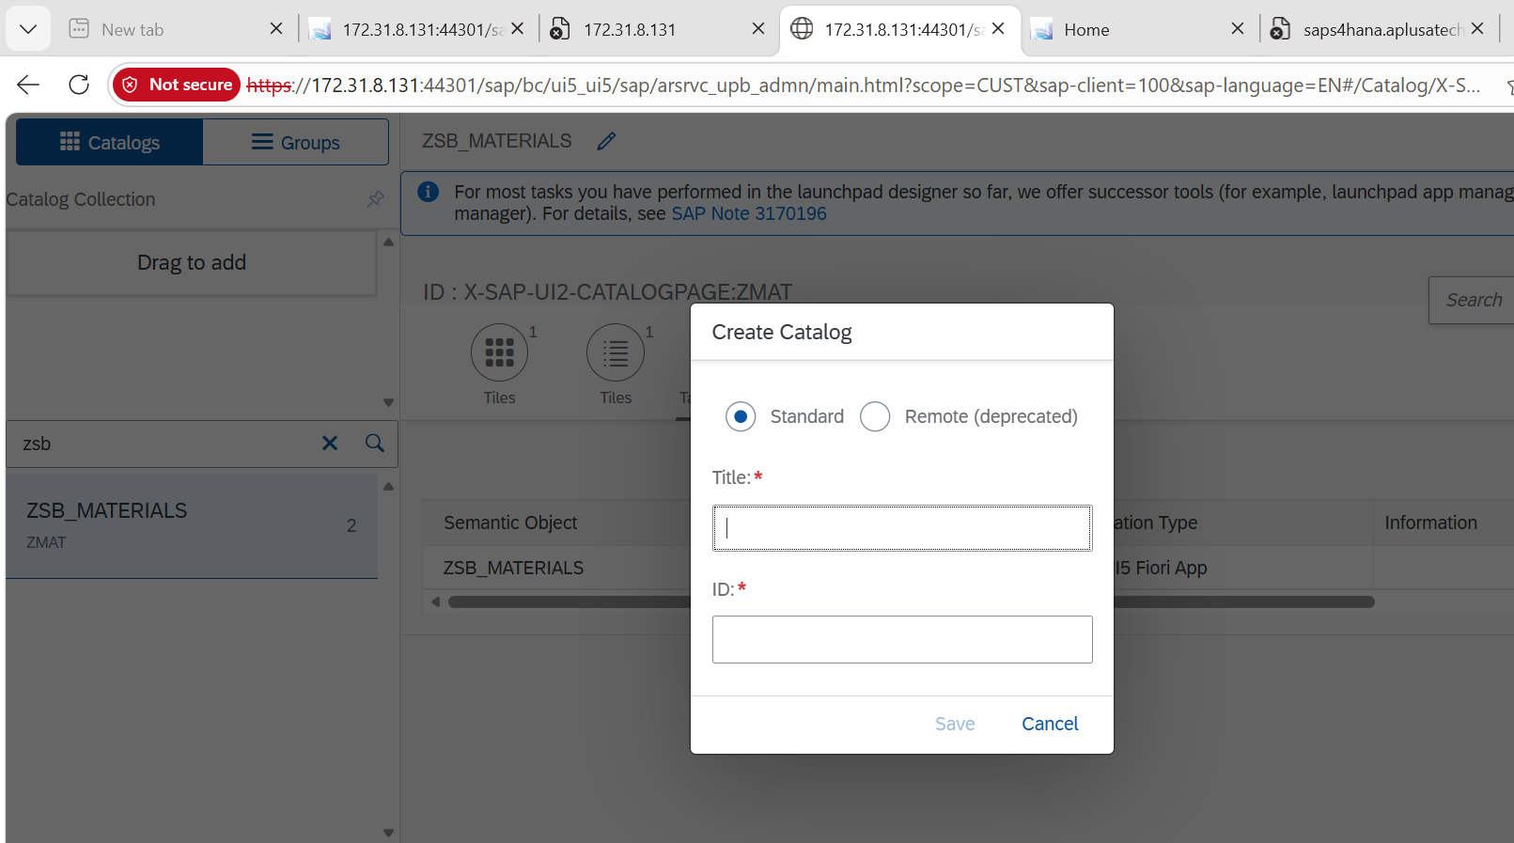
Create Tile :choose static tile ,fill require detail , leave target url empty it fill be filled automatically after getting saved.
Create Target Mapping : fill all the required details and save.
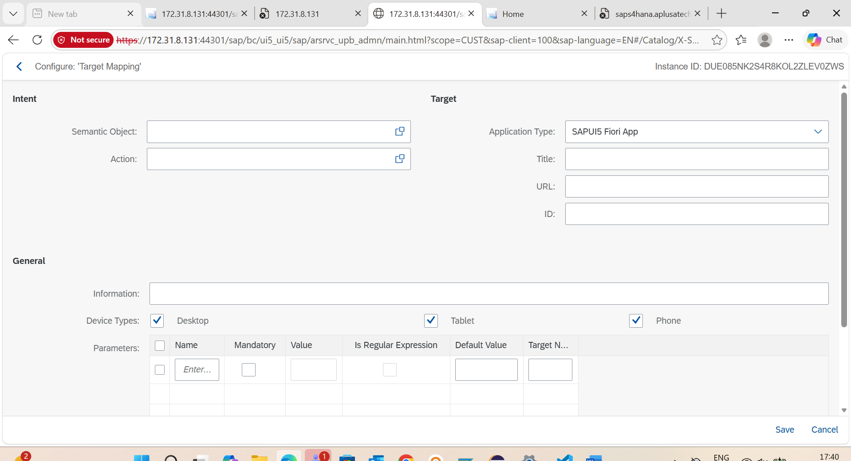
Create Group
Create Roles:
1.goto t code : PFCG
Enter the role name and click single
2. goto menu and create role menu for catalog and group
3. goto user and add required USER.
4.

